No. of Pages | 4
No. of Questions | 8

Department of Computer Science and Engineering
FINAL EXAMINATION SPRING 2012

CSE421: Computer Networks
Total Marks: 90 Time Allowed: 3 Hours

- Answer Any Six (6) questions out of Eight (8) questions.
- Figure in bracket [] next to each question indicates marks for that question.

Question No. 1

- HTTP1.1 uses persistent with pipelining. So when a user requests a Web page that consists of some text and two images; draw the interactions between the server and client. Let RTT denote the round trip time between the user and the server containing the objects. [4 marks]
- What are the main four components that are required to use cookies in an ecommerce website? [4 marks]
- Draw the DNS servers’ hierarchical architecture with examples. [4 marks]
- How is an iterative query in DNS better than recursive query? [3 marks]

Question No. 2

- Suppose an ISP is given a block 12.10.0.0/16. [9 marks]

The ISP needs to distribute these addresses to three groups of customer as follows:
- The first group needs 256 addresses
- The second group needs 128 addresses
- The third group needs 64 addresses
Create subnets as per requirements and show calculations.
- What are the differences between Inter-AS and Intra-AS routing protocols? [3 marks]
- When advertising routes, what are the main attributes or information that BGP helps to send from one router to another? [3 marks]

Question No. 3
Figure No. 3
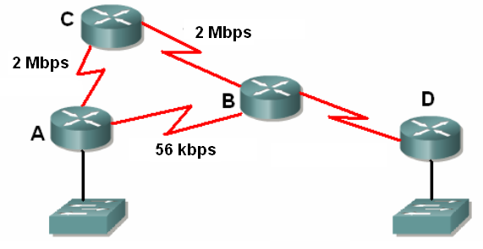
Figure No. 1
- If RIP v2 is running on the networks in the figure no. 1, which path will be chosen as the route for forwarding a packet from A to D and why? [4 marks]
- Router B has received an update suggesting that the route to 192.168.9.0 is down. It has set a holddown timer on the route. What event will cause the holddown timer to be removed? [3 marks]
- Would RIP v2 or EIGRP be the better choice on a large network where convergence speed is important? [3 marks]
- What are the mechanisms available in RIP to avoid routing loops? What would happen to a packet caught in a routing loop if all the distance vector mechanisms for avoiding such loops failed? [5 marks]

Question No. 4

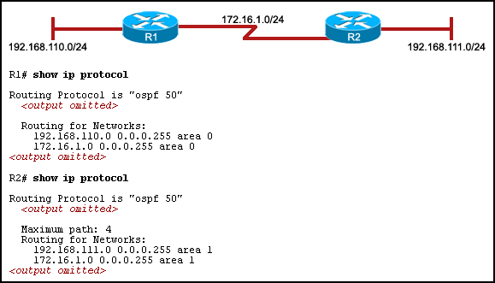
Figure No. 2

- Refer to the exhibit shown in figure no. 2. The hosts that are connected to R2 are unable to ping the hosts that are connected to R1. How can this problem be resolved? [3 marks]

- A router has active interfaces 192.168.1.1, 172.16.3.1, and 10.0.0.1. It has a loopback interface 172.31.255.255. What ID will the router use for the OSPF process? Why? [4 marks]
- Compare OSPF routing protocol with RIPv2 routing protocol. [4 marks]
- What is the disadvantage of having a router ID based on an active physical interface? Why is the router ID needed for routers in the OSPF process? [4 marks]

Question No. 5

- TCP opens a connection using an initial sequence number of 56,000. The other party opens the connection with an initial sequence number of 75,000. Show the three TCP segments during the connection establishment. Be sure to show which control bit flags are set. [4 marks]
- What is a “three acks” for the same packet mean to a sender? [2 marks]
- What is Open Loop Congestion Control? Name some Open Loop Methods and explain one briefly. [5 marks]
- What is the difference between Implicit and Explicit Signaling congestion control? [4 marks]

Question No. 6

- What are the error detection methods used in Ethernet and in IPv4? [3 marks]
- How does NAT create a problem for P2P applications? State one way that allows P2P applications to overcome the problem created by NAT? [4 marks]
- Whenever we wish to test a connection to a device, we use the application “PING”, how does it work and which protocol is it based on? [4 marks]
- Why does IPv4 must further fragment a packet? If fragmentation occurs how a receiver knows that it has received the last packet? [4 marks]

Question No. 7

Gateway of last resort is not set
10.0.0.0/8 is variably subnetted, 2 subnets, 2 masks
C 10.0.4.0/24 is directly connected, FastEthernet0
D 192.168.100.0/24 [90/2195456] via 192.168.4.101, 00:00:08, Serial0
D 192.168.101.0/24 [90/2195837] via 192.168.3.1, 00:00:05, Ethernet0
[90/2195837] via 192.168.3.2, 00:00:03, Ethernet0
C 192.168.4.0/24 is directly connected, Serial0

Figure No. 3

- The above figure no. 3 shows the output from which table? Which value represents the cost of a destination network and how was the cost calculate? [4 marks]
- What are the three tables that EIGRP maintain? And what kind of information does EIGRP store in them? [4.5 marks]
- What is the advantage of EIGRP storing feasible successor routes as well as successor routes?
[2.5 marks]
- A router running EIGRP finds 3 routes to the same destination.
Route A has FD 3523840 and RD 3011840
Route B has FD 2297856 and RD 39260
Route C has FD 3558000 and RD 2115200
Which route/s will become the successor and feasible successor/s? Explain your answer. [4 marks]

Question No. 8

- In IPv6 it is said that anycast addresses are the same as unicast addresses, yet they are different, how? . [3 marks]
- Write a short note on IPv6 address notation. [4 marks]
- How is Tunneling better Dual Stack in IPv6 transition? [4 marks]
- In IPv6 header, there are no fragmentation fields, so fragmentation is no longer required, true or false, justify your answer. [4 marks]

THE END

